C211 Readings & Assignments: Week 2

Week 2 Reading
Complete the following reading early in the week:
- Week 2 online lectures.
- From your course Textbook, Storyboards, Motion in Art, read the following chapters:
*Chapter 35: Portfolios
*Chapter 20: Style
*Chapter 26: Illustrated Camera Techniques
*Chapter 30: Conceptual Illustration
Week 2 Assignments Overview
Assignment Summary: Week 2 | Due Date
Assignment 1: Discussion Questions | Friday, November 21, 2008
Assignment 2: Coloring Exercise | Sunday, November 23, 2008
Assignment 3: Storyboard Exercise | Monday, November 24, 2008
Remember that all assignment details can be found on the assignment pages located throughout the week. Go to those specific pages for direction on how to complete each individual assignment.

Week 2 Overview
This week we move on to enhancing the storyboards using appropriate colors, images, art styles, and cinematic techniques. We'll also discuss establishing a mood in storyboards.

Effective Use of Colors in Storyboards
Storyboards can consist of panels with hand drawn sketches (mostly production boards) or colored panels with a lot of detailing (mostly presentation boards). We'll talk about these two types of storyboards in the fourth week. However if the requirement is to enhance the boards using colors, it is important to understand the effective use of colors first. You may be working with any format of visual imagery, such as games, films, or television. Whatever the format, the use of color is an important component of your creative toolbox.
When developing interactive products, the designer must always ensure that the color reads well and helps separate moving objects from the background. In most cases, the color in the background will be digitally painted in the same fashion as the cast of characters. When the dominant color of a character is too similar to the background there is a good possibility that the character might blend into the background, thereby hampering the depth of field.

Use of Dominant Colors
Brilliant red, as a dominating color, tends to reflect imminent danger. An abundance of orange indicates the possibility of intense heat. Blues and grays depict a coldness that often comes with gloom and doom. Bright colors tell a happy story whereas pale pastels are much more subtle and, in some cases, even morose. The audience should experience it in a way that maintains their interest and stirs their emotions. In multiple segments, it is a good policy to make sure that no color is being overused. Color needs to be broken up at times to avoid dominating the look of a production.

Learning Outcomes:
• Incorporate principles of color theory into interactive products
• Apply graphic design principles to visual aspects of animated sequences
• Apply principles of visual literacy of design
• Create a storyboard and render a short animated sequence
• Submit portfolio of images for short animated sequence
• Apply proven cinematic disciplines to project
• Apply the main essentials of storytelling
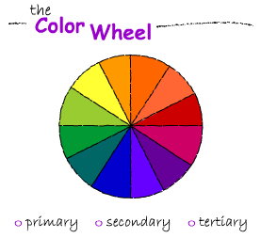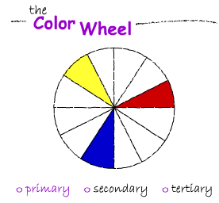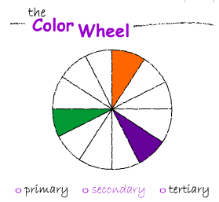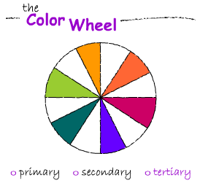

Creating and Establishing the Mood
When it comes to teaching entertainment arts, in particular animation, it is next to impossible to talk about one discipline without recognizing others as well. Creating a mood for a game, film or television production is no different than animations. You need to bring everything into play—how it is going to look, how it is going to sound and, above all, how it is going to feel.

Establishing Mood Through the Overall Look
Starting with how the final product will look, let's begin with the artistic approach that is to be taken. There needs to be a specific direction established if the mood is to be apparent. Your knowledge of art history can be most helpful in this area. The earlier art periods are easier to identify but as you move closer to the modern age they become a bit more obscure. A keen awareness of great illustrators and contemporary artists can make the difference in a project that is a big hit and one that flops.
Take a minute to think and recall the artistic styles being used in animated productions. If you cannot think of any, it isn't because there aren't many, it's because you aren't aware of just how many there are!

Establishing Mood through Sound
Interestingly, a discussion about Fantasia provides an excellent segue into the next component for establishing mood and that is music. Each scene of animation can be dramatized greatly by the style of music used to accompany it. Action scenes, horror scenes, chases, cliffhangers and other dramatizations are much more effective when the right music is included. In the animated version of The Legend of Sleepy Hollow the scene of Icabod Crane being chased by the Headless Horseman is hilarious. If you were to screen this segment with the music track muted, it would not be nearly as effective.

Establishing Mood through Characters
Remember the three essential elements of drawing skills − structure, gesture, and contour? Gesture is used to create a mood for a character. It is vital for the cast of any production to reflect a mood. Therefore each pose of every character you draw or create should reflect a mood of some sort. Work on the emotions your character displays. Consider body language in the poses. If the character is sad, make him really sad. The body should slouch like the whole weight of the world is upon him. If he is happy, let it show. Chest out! Head up! Shoulders back! Make sure the acting is present--this makes the mood convincing.
Is animation real? How can it be real, it's only lines and color? Study the scene from Dumbo when baby Dumbo has to leave home for the first time. This scene stirs the emotions of the viewers noticeably, especially when Dumbo takes one last look over his shoulder, and a tear drops from his eye. Anyone with a soul gets a bit choked up by this. So, asking the question again, is animation real? To the subconscious mind it is real because the audience can relate with it. How else would it stir the emotions in this manner? This case proves a very important fact of human nature - the subconscious mind cannot always distinguish the difference between fact and fantasy. Also the power presentation of a character helps in establishing the mood of a scene.

When to Establish the Mood
Going back to the basics of storytelling, always remember that the mood of the scene needs to be identified in the beginning of a segment. Remember also that anticipation is a very effective animation principle. If the audience can see the mood coming it is much more effective. It is as if you are saying to them I am going here (point to a location) and then go precisely there. The audience stays with you and you have their undivided attention. Your work always needs to be a showstopper if possible. In other words, if a person is walking through a room where one of your productions is playing, he or she will stop out of curiosity because they are intrigued and want to see more!

The Role of Timing
The timing of the scenes is also crucial to setting the mood. A chase scene is more dramatic with a lot of quick cuts, reverse angles, and dynamic camera positioning. A majestic scene is much more appealing if the shots are slow moving pans and zooms. Knowing when to cut to a close-up is an art in establishing the mood for a particular shot. Study the work of great filmmakers and analyze the techniques they used and then apply the techniques to your own projects.

Finally…
You should always ask yourself these critical questions. Does the mood you are creating help tell the story properly? Is it the right mood? Does it reflect a feeling of sadness when it should be joyful?
These questions can all be answered with plain common sense. Apply your good sense to every scene. The answer to all of these questions is within you, and can be coaxed to the surface through practical application.

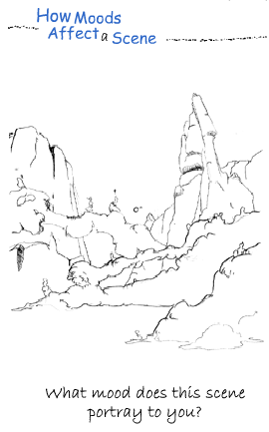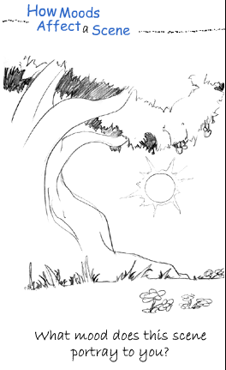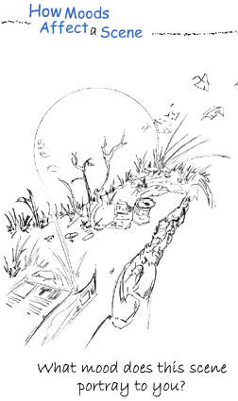

Using Basic Shapes Effectively
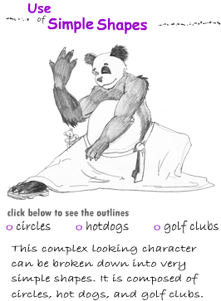
Using simple shapes like circles, ovals, and triangles in the storyboards helps to illustrate the scene convincingly. Selecting shapes will only work effectively when they are illustrated clearly. Each link in the chain of storyboard production is connected to the others. Color theory knowledge, for instance, is wasted if it is applied to a poorly drawn image. Your success as a storyboard artist depends largely upon the knowledge you have acquired in all elements of art. Selecting effective shapes is just one more of these elements.
Whether you are working on a three-dimensional or two-dimensional project, the approach should always be three-dimensional. When building wire frame characters, you are generally forming images from basic shapes. Hand drawings work in the way similar to building wire frame characters because using basic shapes for a structure is an excellent way to draw in a three-dimensional manner. Another reason for using basic shapes is to help in training. On larger productions, several animators may be working on the same character. As the creator of a certain character, you will obviously know how to draw it correctly, but there may be other animators drawing the character as well. Identifying basic shapes within the structure of a character, as we did with the bear on the previous page, is a good way to teach others how to draw the character correctly.
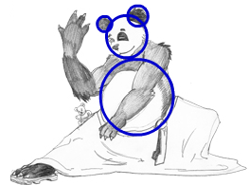
Symbolic shapes can work for you and sometimes against you. A heart for instance is a symbolic shape everyone will recognize and associate with love and affection. A red octagon generally tells someone to stop. But a lack of knowledge about the meaning or use of symbolic shapes can prove embarrassing to a designer and offensive to the audience. Phallic symbols have strong sexual overtones that need to be approached with a certain degree of caution. The Swastika started out as an Indian symbol but became associated with Nazism during World War II. Therefore, when you are using symbols in storyboards you need to be sure of the meaning conveyed by the symbols.
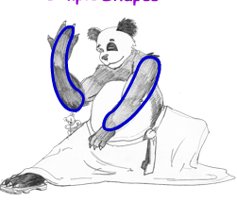
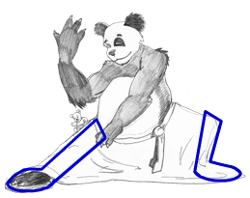
Keeping it simple is also a good policy. Remember that everything that does not add to a drawing takes away from it. Try to avoid cluttering up your work with too much detail; animation demands this. When creating costumes, you should indicate detail rather than fully draw it. In other words, don't put in five stripes if you can use three instead.
Simplification is essential when you are creating hundreds, if not thousands of drawings to create motion. Not only does unnecessary detail greatly increase your production time; it tends to make the character look too busy as well. Consider that on some occasions, less is more. For instance taxes ... get the picture?
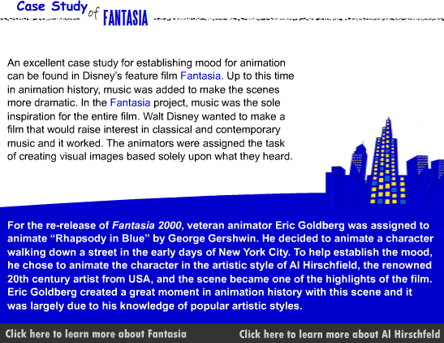
Fantasia - http://disneydvd.disney.go.com/fantasia.html#3865
Al Hirschfeld - http://www.bpib.com/illustrat/hirschfe.htm#navigate

Use of Cinematic Techniques

Keeping the Overall Picture in Mind
As you enter into the incredible world of animation, you should consider yourself a professional filmmaker. This is the perspective you should always strive to maintain in order to achieve the highest standards of excellence in your work. To be a filmmaker you must learn to see everything through the eye of the camera. This is one of the last things aspiring animators concern themselves with because they are so preoccupied with motion theory. Once again, it is difficult to talk about one animation discipline without mentioning others because all come together in the final mix. You are not just an animator—you are directing the scene as well. If you were directing a live action set, how many cameras would be necessary in order to capture the moment and keep the attention span of the audience at the highest level possible?
View your shot from overhead, as though you were looking at a stage. Where would be the most advantageous position for the cameras to be placed? In the case of game art, the user might be "directing" the camera path by playing the game, but the viewfinder is still established by the game designer. But in games that are displayed from a fixed position, the designer can get pretty creative in establishing just what those fixed positions are.

Identifying Appropriate Camera Angles
Cinematic techniques cover a broad range of options and effects. In order to think like a camera you must learn to communicate cinematically, especially in naming shots. Most shot descriptions are self-explanatory. An extreme close-up (ECU) fills the lens with the subject as close as possible, either for showing a lot of detail on an object or for seeing facial features such as on shows like 60 Minutes. The medium close-up (MCU) is the same thing but not quite as tight on the subject. The medium shot (MS) generally will include the head and shoulders in the shot. When more than one person is on camera the shot is referred to as a 2 Shot or 3 Shot, whatever the case may be. A wide shot (WS) will usually include the entire character from head to toe. The extreme wide shot (EWS) is a panorama that may include mountains, city skylines, and other camera views that cover vast amounts of space.

Camera Movements
Directors also use camera movements to keep the action alive. Let's quickly recap these movements. The PAN is a shot in which the camera, set in a fixed position and mounted on a tripod, rotates to follow the action horizontally. On the other hand, in a DOLLY MOVE, the camera moves on wheels along side the action, or forward and away from the action. The TILT is similar to a PAN; only the camera rotates in a vertical direction. A PED move or crane shot is similar to a DOLLY MOVE, but the camera movement is vertical as well. The ZOOM of course is racking the lens in or out on the subject.
Learn the language of the Camera - http://www.animationmeat.com/pdf/featureanimation/perfectpan.pdf

Director Cues
In addition to identifying the many camera angles, there are several director cues to be identified as well. Most of these will be familiar to you, but we will go over them for clarity. Most establishing shots are done with a fade in (FI), which goes from black to full resolution in a prescribed time frame. The reverse is true in a fade out (FO). The dissolve (DIS), sometimes called a lap dissolve or cross dissolve blends from one scene into another. A cut (CUT) is not the end of the scene but the end of a particular shot, an indication that camera should switch to another angle. Positioning of cameras can also go to extremes, such as a worm's eye view (extremely low angle) or a bird's eye view (extremely high angle). An experienced director learns to think and communicate in these terms. An experienced animator must do the same.

Use of Lighting and Shadows
Among the many hats the animator must wear, (referred to in the lectures from Week 1), is that of the Lighting Director. In order to think cinematically, it is important to become familiar with the technique of "painting with light." Sophisticated animation software packages make this technique possible just as though you were lighting a set for live action. The lighting can be soft or harsh, depending on the effect you want to create. Is the scene supposed to be stark or mellow? The use of color gels over light can produce a variety of effects. If a subject happens to be at the scene of an accident, perhaps the close up of the face might also include the glow of flashing red lights to enhance the drama. Similarly the presence of other objects like a television or situations like fire and explosion can be reflected on the face of a person by using lights effectively.
The more familiar you become with the language of filmmakers, the more versatile you will become in creating entertaining scenes. It is also important to never lose sight of the fact that high-end software programs are designed to operate at this level as well.
Summary
This week we looked at enhancing the storyboard by using colors, art styles, and cinematic techniques. Incorporating these elements into your storyboards will help you tell a story clearly.
Film Lingo: http://www.rivalquest.com/filmlingo/#A
Assignment 1: Discussion Questions
By Friday, November 21, 2008, respond to the discussion questions assigned to you by the facilitator. Submit your responses to the appropriate Discussion Area. Start reviewing and responding to your classmates as early in the week as possible.
Assignment 1 Grading Criteria and Respective Point Value | Maximum Points
Response Criteria
Met the criteria for the correct responses to the questions assigned | 4
Used vocabulary relevant to the current week's topics - at least four terms | 4
Participation Criteria
Used vocabulary relevant to the current week's topics - at least four terms | 4
Participated in the discussion by asking a question, providing a statement of clarification, providing a point of view with rationale, challenging a point of discussion, or making a relationship between one or more points of the discussion | 4
Justified ideas and responses by using appropriate examples and references from texts, websites, and other references or personal experience | 4
Total: | 20
For assistance with any problems you may have when completing this assignment—OR—to offer your assistance to classmates, please use the Problems and Solutions Discussion area located through the left side navigation link.
Hello everybody, please respond only to Question 1. Create two layout sketches depicting contrasting moods. Please spend time producing these sketches. Think how you can depict the mood, maybe camera angles, different tonal values, light and shadow, low or high horizon, high contrast or low contrast and more. Maybe you could show different options? Thank you guys, Andrzej
Review the video release of The Lion King from Disney, Buena Vista. Discuss how the developers have established the various moods in the following scenes:

- The stampede
- The Elephant Graveyard
- The variations of Pride Rock
- The changes in scenery after 'Scar' takes charge
- The contrast after 'Simba' returns from exile
Take one of these scenes, and create two layout sketches that depict contrasting moods. By Friday, November 21, 2008, scan and submit these sketches to the same Discussion Area for critique.

Dq2 - Write a brief review describing one of your favorite films. Describe the disciplines that made it work so well in your mind. Focus on the visual treatment of the movie.
Dq 3 - Discussion Question 3 Interview/Get views of a game storyboard artist on how a game storyboard is different from other forms of storyboards and share your findings with the class. You can visit the following URLs for information on storyboard artists:

- http://www.gamasutra.com/php-bin/galleries.php?gallery_id=20
- http://www.filmbiz.com/professionals/Storyboard_Artist.php

Dq4 - Think for a moment about a film, 3D game, or animated TV series in which you noticed excellent camera work. Discuss one of the scenes where camera is positioned/moved effectively. Describe the scene and explain the basis for deciding the correct camera angle/position/movement in a scene.
Dq5 -You have learned about the techniques, processes, and practices prevalent in the well-established film and TV industry. Explain how these are applicable to the game industry. Are some modifications needed for developing storyboards for games? If yes, what are those modifications and why are these needed?

Assignment 2: Coloring Exercise
Download the line art.jpg file. Use this file to create a separate color scheme that depicts each of the moods listed below. The line art can be printed and color applied by marker, pencil or any medium preferred, then scanned for submission or painted digitally with software.
- Gloomy
- Romantic
- Cheerful
- Mysterious
By Sunday, November 23, 2008, scan and submit the four images to the appropriate Discussion Area. Review and critique the work of at least two other students by the end of the week.
Assignment 2 Grading Criteria and Respective Point Value | Maximum Points
Displayed the mood of the scene correctly | 8
Showed contrast of colors in each rendition | 4
Depicted noticeable differences from one drawing to another | 4
Provided valid and meaningful comments to at least two other students (2 X 4 points) | 8
Total: | 24
For assistance with any problems you may have when completing this assignment—OR—to offer your assistance to classmates, please use the Problems and Solutions Discussion area located through the left side navigation link.
Welcome to assignment 2. Please attach your work here to DISCUSSION THREAD
Assignment 3: Storyboard Exercise
Finalize the thumbnail boards created by you in Assignment 4 of Week 1 by incorporating the comments of the reviewer and work out a set of storyboards in full size, with color applied. Be sure to include camera cues and soundtrack information. Scan and post the storyboards to the appropriate Discussion Area, by Monday, November 24, 2008. Using information from this week's lectures and readings, review and critique the work of at least two other students as early as possible.
Justify/Improve your storyboards based on the comments you get from other students and submit the final work of the storyboards to the facilitator by the end of the week.
Assignment 3 Grading Criteria and Respective Point Value | Maximum Points
Incorporated suggestions from Week 1 | 4
Provided constructive criticism | 4
Justified or improved storyboards | 8
Followed the flow and continuity of the thumbnail | 8
Used proper camera instruction | 4
Total: | 28
For assistance with any problems you may have when completing this assignment—OR—to offer your assistance to classmates, please use the Problems and Solutions Discussion area located through the left side navigation link.
Hello everybody, please post your assignment here in discussion thread.

